You are cordially invited to attend the

Eagle Scout Court of Honor
for
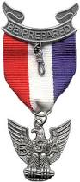
James John Doe

Fri. May 25, 2018 at 7 pm
Jet Propulsion Laboratory
von Karman Auditorium

refreshments following ceremony

